ANNEX 1: Tutorial to Appnote 23: calculating with ellipses

Below, complimentary to the AN0023 by Will, follows:
- Explanatory sketches clarifying the variable used by the c47/R47 implementations,

- Explanatory notes relating to the sketches,

- Two worked examples, complete with detailed diagrams,

- 20 problems with solutions, verified on C47/R47, excerpted from Baker, 1890 (see footnote 1 below).

Let me quote Baker from 1890 (see footnote 1 below):

It is in the hope of smoothing the road to this interesting and increasingly important branch of Mathematics, and of putting within reach of the English student a tolerably complete outline of the subject, clothed in simple mathematical language and methods, that the present work has been compiled.

New or original methods of treatment are not to be looked for. The most that can be expected will be the simplifying of methods and the reduction of them to such as will be intelligible to the average student of Higher Mathematics.

Funny that in 1890 already, this work was considered mature enough to not want new fashioned treatments ;-) 130 years later the R47/C47 implements still the same math with no new treatments.

R47/C47 X.FN menu R47/C47 Elliptic / Jacobi functions:
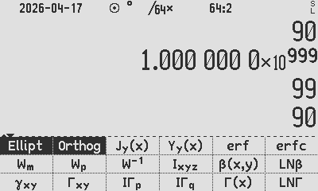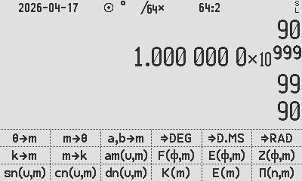
Fig. 1: The worked examples below can be replicated with the R47/C47 Ellipt menu functions above:

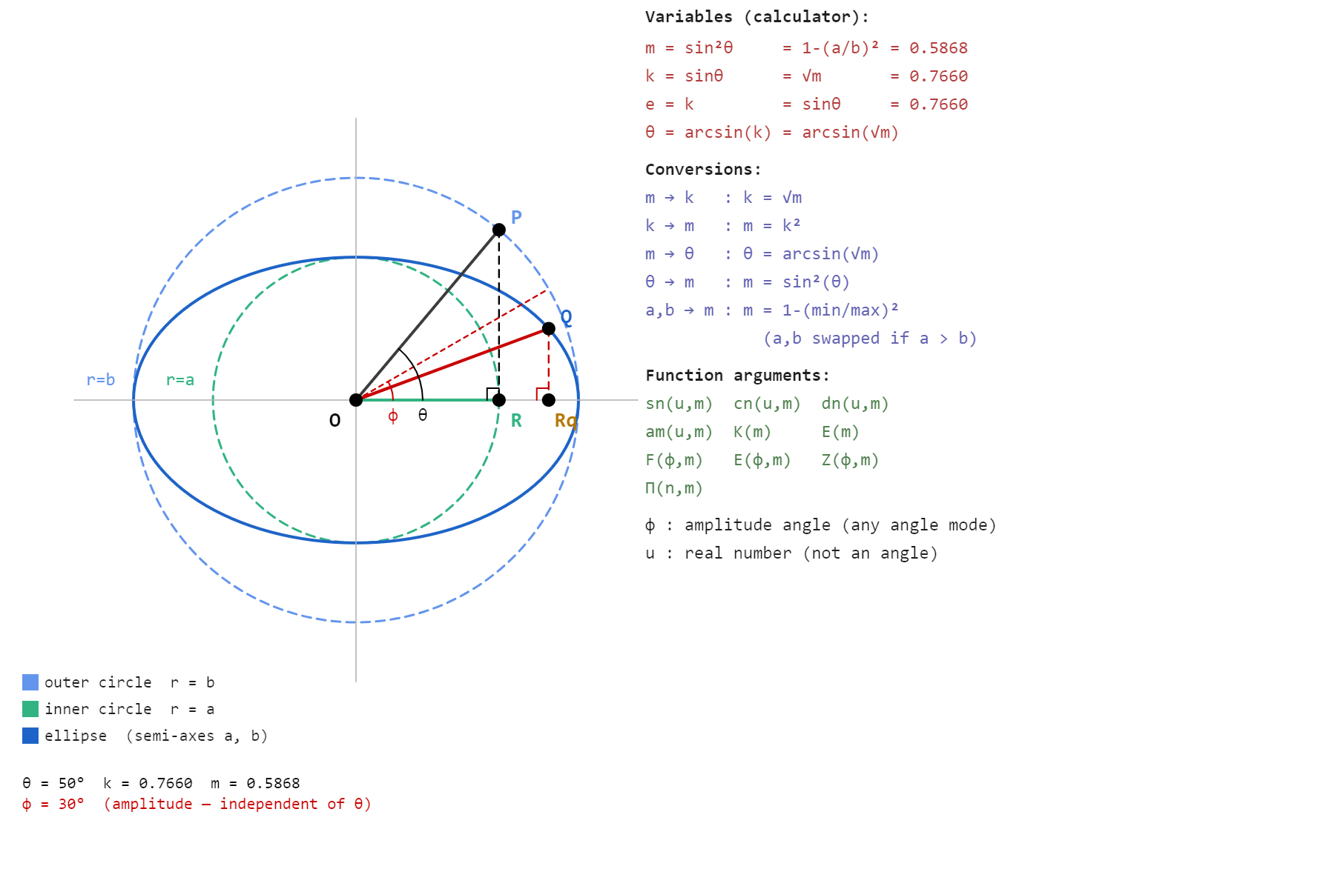
Fig. 2: Ellipse definition & command summary
The ellipse above is fully described by its two semi-axes a and b. From these the calculator parameter m = 1−(a/b)² and modulus k = √m follow directly.
The eccentricity angle θ = arcsin(k) ties the ellipse shape to the function parameters. With P on the outer circle at angle θ, the vertical from P drops to R on the major axis and OR = a, giving cosθ = a/b. If a and b are known, m = 1−(a/b)² follows directly. If the ellipse is given as a drawing, θ is the angle to measure to get m without needing to know a and b explicitly.
For a point Q on the ellipse, the amplitude angle φ gives the coordinates of Q through the ellipse equations x = b·cosφ and y = a·sinφ. This is the critical distinction the diagram is meant to convey: φ is not the geometric angle QOR visible in the figure, which would be arctan(y/x) evaluated at Q.
The two different angles θ and φ, at the same point, are most easily confused.

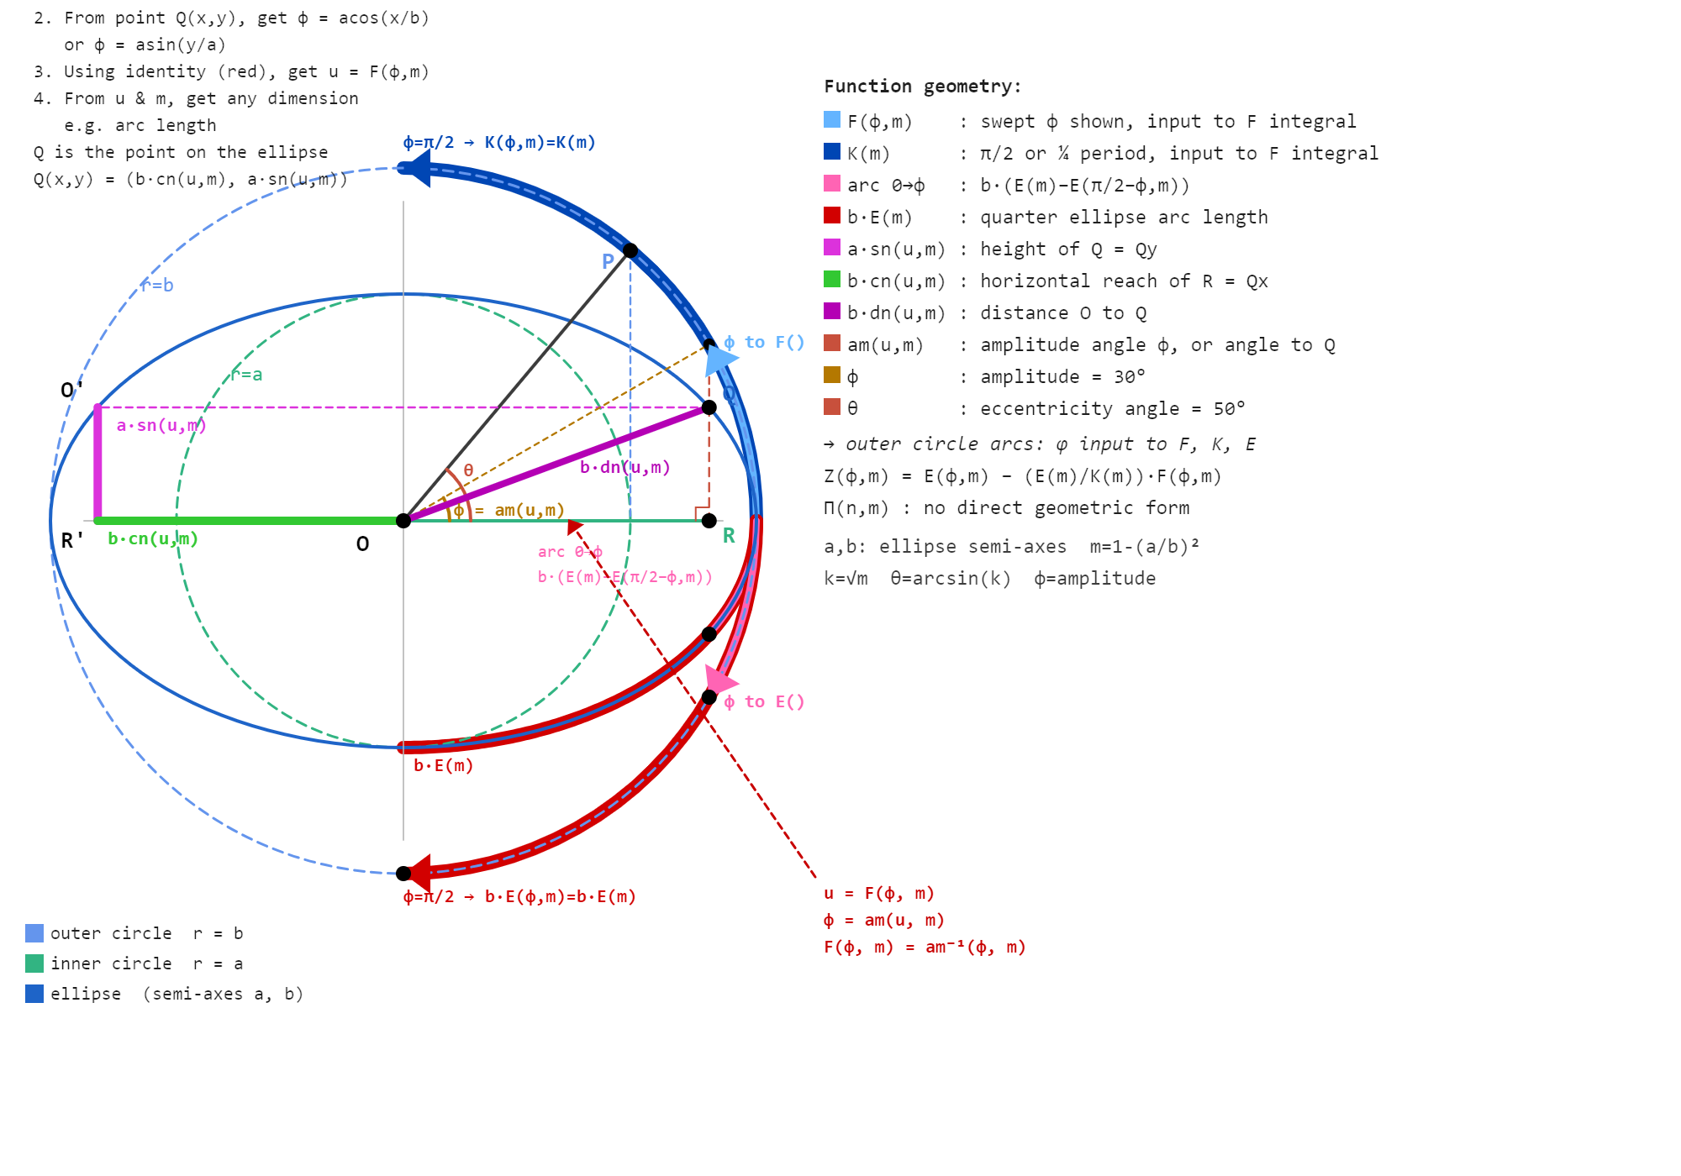
Fig. 3: Elliptical Function Summary and clarification

Once m and φ are known, u = F(φ,m) is the single quantity that unlocks all Jacobi functions. F is the inverse of the amplitude function: φ = am(u,m), so u is simply the argument whose amplitude is φ. The diagram shows this geometrically — the blue arc sweeps φ as input to F, and K(m) = F(π/2,m) is the same function evaluated at its quarter-period input.
The arc length along the ellipse from 0 to Q is b·(E(m) − E(π/2−φ,m)), not b·E(φ,m). The distinction matters in practice: E(φ,m) alone does not give arc length except at the quarter period where it equals b·E(m) exactly. The correction term E(π/2−φ,m) accounts for the asymmetry of the integrand between the two ends of the quarter arc.
The segments b·cn(u,m), a·sn(u,m) and b·dn(u,m) form a right triangle OQR, so once u and m are known all three dimensions of Q are available simultaneously.
A single call to F gives u, and from u the full geometry of the ellipse follows in one step.

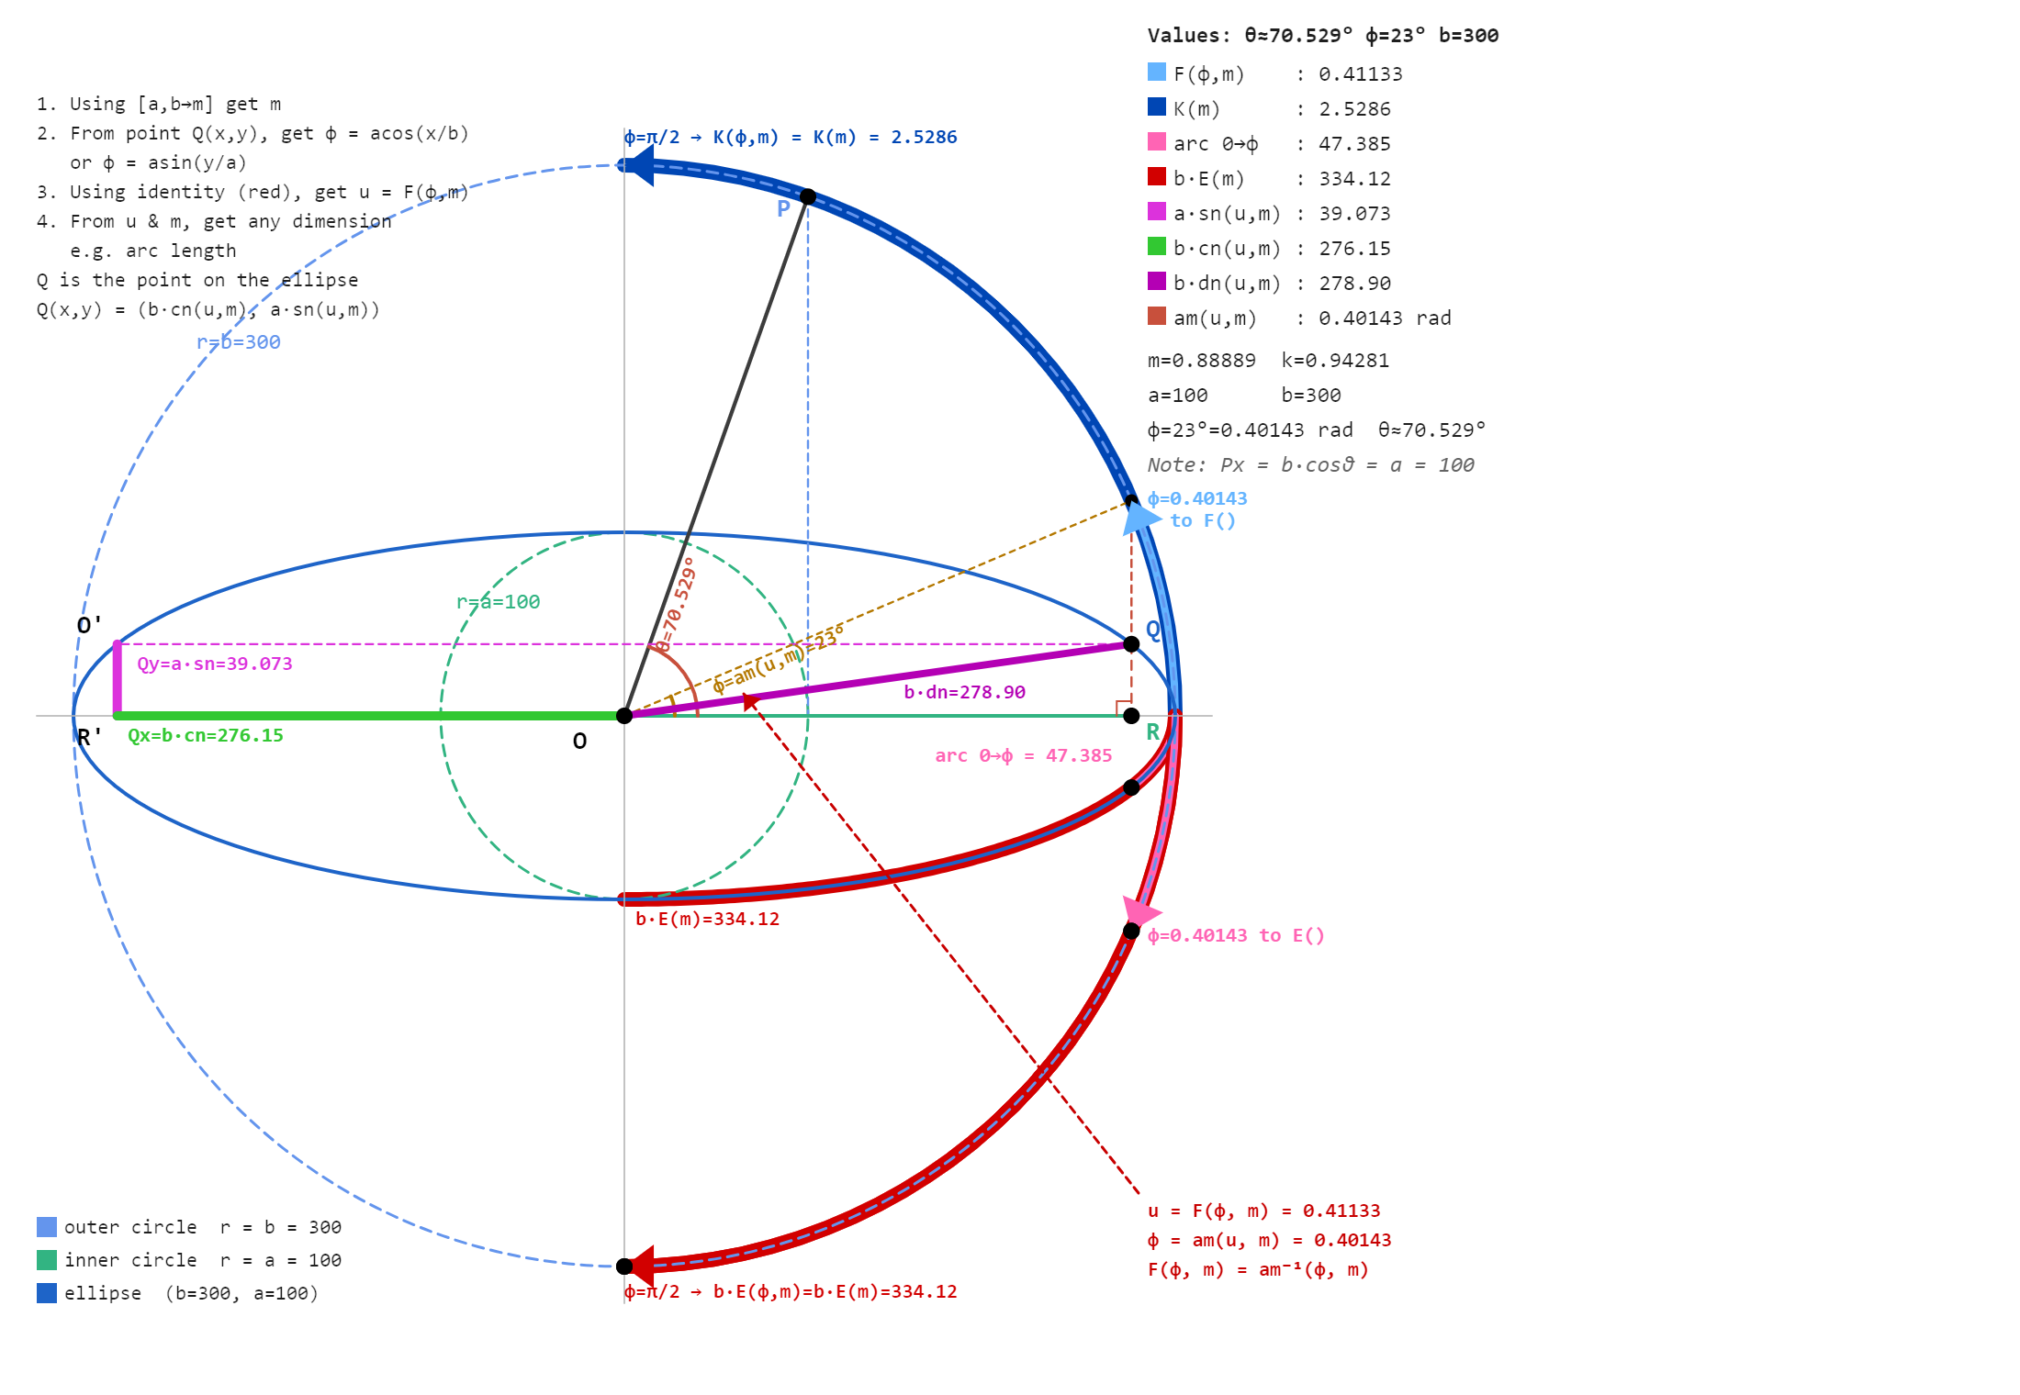
Fig. 4: Elliptical Numerical Solutions 1

Above, the highly eccentric ellipse with a=100 and b=300 which gives m=0.889 and k=0.943. At this eccentricity the elliptic functions behave quite differently from a near-circular case, and the geometry is more visible precisely because the ellipse is so elongated.
The instruction block top left gives the workflow in four steps: get m from a and b, get φ from the coordinates of Q, get u from F(φ,m), then read off any dimension. Everything flows from m and φ.
The blue arc shows φ=23° being fed into F. The output u=0.41133 is neither an angle nor a length and does not appear on the drawing. It is the argument to all the Jacobi functions. From u and m the calculator returns b·cn=276.15, a·sn=39.07 and b·dn=278.90 as the three sides of the right triangle around the point on the ellipse, i.e. OQRq. K(m)=2.529 is F evaluated at φ=π/2, the quarter period input.
The arc OQ along the ellipse is 47.385, obtained as b·(E(m)−E(67°,m)) where 67°=90°−φ. The full quarter arc b·E(m)=334.12 is considerably longer than a less eccentric ellipse would give, reflecting how much the curve stretches near the major axis when k approaches 1.
The red identity block (bottom right) states u=F(φ,m) and φ=am(u,m) as inverses.
To solve the ellipse, starting with a coordinate, arc length, or angle, requires finding φ, then u.

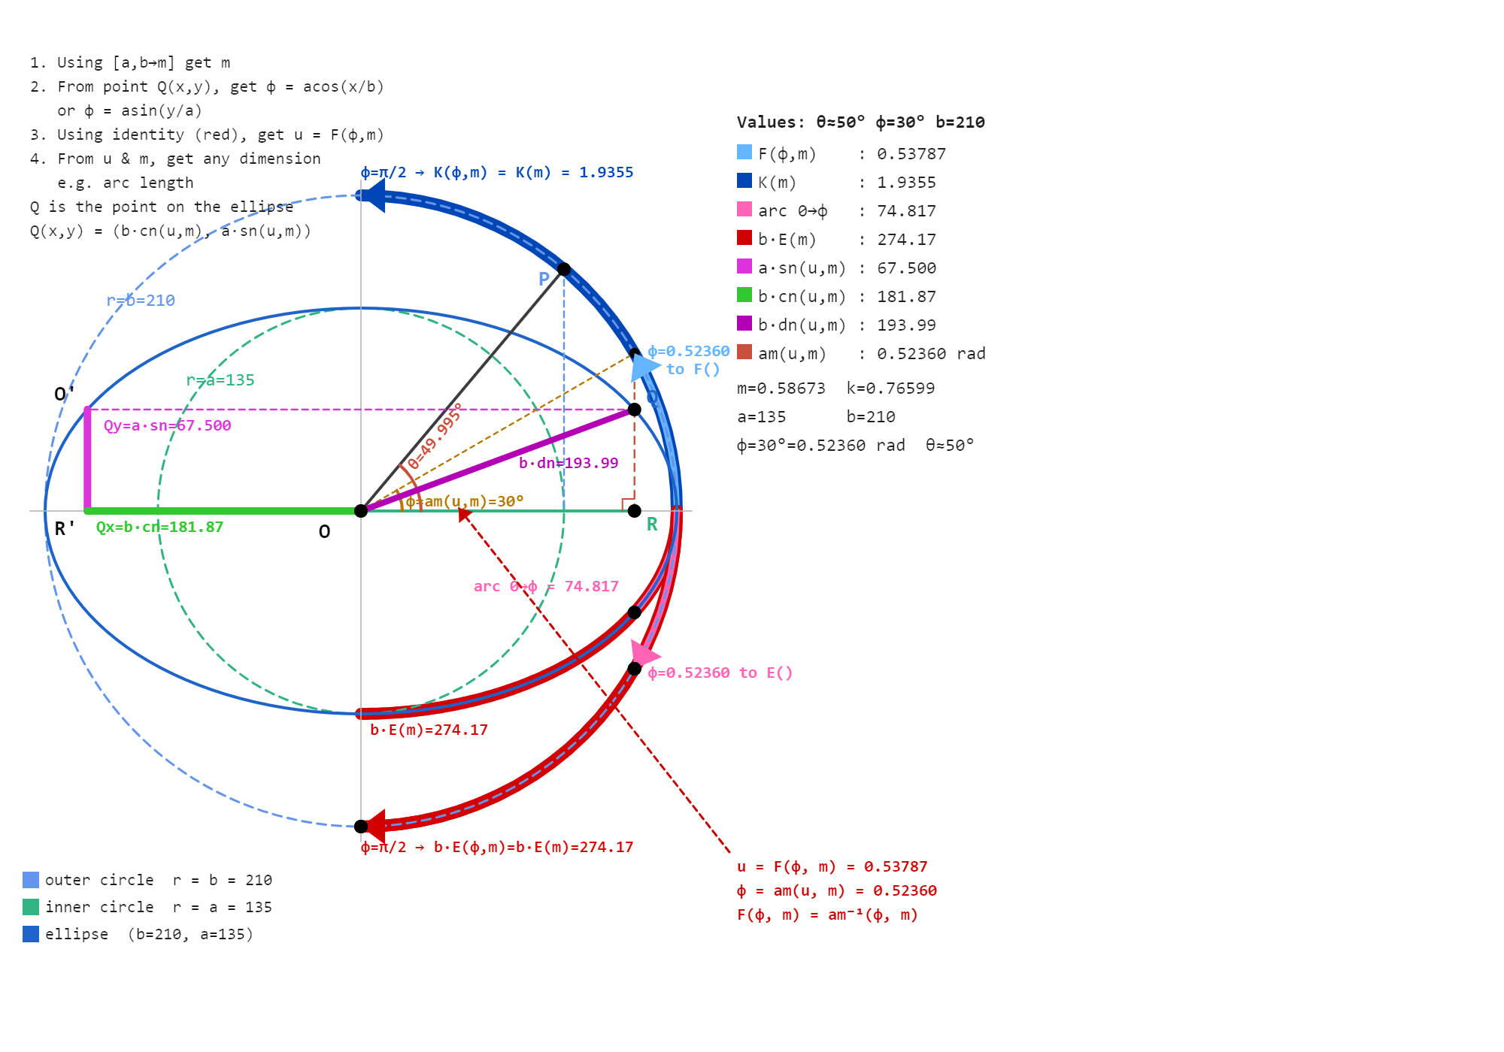
Fig. 5: Elliptical Numerical Solutions 2

Second exercise left to user, with no comments

Examples from Baker,
- p.106: Let k= sin θ= sin 19°30′. Required K. K= 1.615101 (ed. Printing error. 3 digits correct in the book; log K was given correctly as log K=0.208852, implying their log-book lookup was wrong).

- p.108: Given k= sin 75°. Find K. K= 2.768064 Ans.

- p.109: Given k= sin 45°. Find K. K= 1.8540747 Ans.

- p.110: Given θ= 63°30′. Find K. Ans. log K= 0.3539686

- p.110: Given θ= 34°30′. Find K. Ans. K= 1.72627

- p.111: Let ϕ = 30° k= sin 45°. Find u. u =0.535623, Ans.

- P.113: Given k= sin 75°, tan ϕ = √(2/√3). To find F(k, ϕ). F(k, ϕ) = 0.9226878. Ans.

- p.117: Given ϕ = 30°, k= sin 89°. Find u. F(k, ϕ) = 0.549297. Ans.

- p.118: Given = 79°, k = 0.25882. Find u. Ans. u = 0.39947. (ed. Printing error: 1.39947).

- p.118: Given = 37°, k = 0.86603. Find u. Ans. u =0.68141.

- p.119: Given u = 1.368407, θ = 38°. Find ϕ. ϕ = 72°. Ans.

- p.122: Given u = 2.41569, θ = 80°. Find ϕ. Ans. ϕ = 82°

- p.122: Given u = 1.62530, k = 1/2 . Find ϕ. Ans. ϕ = 87°

- p.123: Given k= 0.9327, ϕ = 80°. Find E(k, ϕ). E(k, ϕ) = 1.0562 (Ed. Incorrect, it is 1.06349)

- p.123: Given k= sin 75°, tan ϕ = √(2/√3). To find E(k, ϕ). E(k, ϕ) = 0.7387196. Ans.

- p.127: Given k = sin 75°. Find E(k, π). E(k, π) = 1.076405. Ans.

- p.127: Given k =sin 30°, ϕ = 81°. Find E(k, 0). Ans. E(k, 0) =1.33124.

- p.127: Find E(sin 80°, ϕ = 55°). Ans. 0.82417.

- p.127: Find E(sin 27°, ϕ = π /2). Ans. 1.48642.

- p.127: Find E(sin 19°, ϕ = 27°). Ans. 0.46946.

Author Jaco Mostert Copyright (C) 2026 The C47 Development Team. Permission is granted to copy, distribute and/or modify this document under the terms of the GNU Free Documentation License, Version 1.3 or any later version published by the Free Software Foundation; with no Invariant Sections, no Front-Cover Texts, and no Back-Cover Texts. A copy of the license can be downloaded from gnu.org.

Baker Arthur L, Elliptic Functions An Elementary Text-Book for Students of Mathematics, New York John Wiley and Sons, 1890, re-released Project Gutenberg, January 25, 2010 [eBook #31076]

